HELLENIC ANTI-MONEY LAUNDERING AND ANTI-TERRORISM FINANCING COMMISSION

Statistics

Key figures from 1/9/2008 to 30/4/2009

 |  | REMARKS
NUMBER OF STRs RECEIVED | 1708 | * This number includes the total of 80 requests, received in this period from FIU-counterparts
NUMBER OF CASES OPENED | 1545
NUMBER OF CASES FOR INVESTIGATION | 1239 | Under investigation
NUMBER OF CASES CLOSED WITHIN THE FIU | 266
NUMBER OF CASES RESULTING IN PROSECUTIONS | 40
NUMBER OF CASES RESULTING IN SEIZURE OF ASSETS | 9
NUMBER OF FREEZING ORDERS ISSUED BY THE COMMISSION | 38
REQUESTS TO FIUS | 32

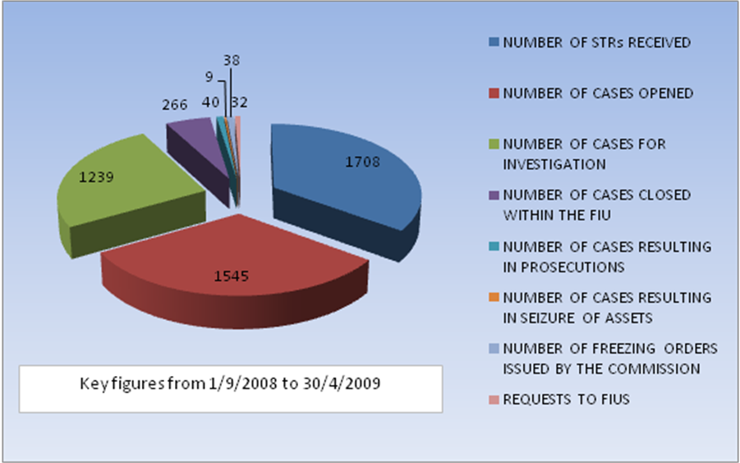

BREAKDOWN OF THE REQUESTS FOR INFORMATION RECEIVED FROM FIU COUNTERPARTS (1/9/2009-30/4/2009)

Country | 2008  (1/9/2008-31/12/2008) | 2009  (01/01/2009-30/4/2009)
ALBANIA | 2 | 1
ARMENIA
AUSTRIA
BAHAMAS
BELGIUM |  | 2
BOLIVIA
BRAZIL
BULGARIA
COSTARICA |  | 1
CROATIA |  | 1
CYPRUS | 5 | 1
CZECH REPUBLIC
DENMARK | 1 | 2
F.Y.R.O.M. | 1 | 3
FINLAND
FRANCE | 1
GEORGIA
GERMANY
GUATEMALA
HUNGARY
INDIA | 1
IRELAND
ISLE OF MAN |  | 1
ISRAEL
ITALY | 1
LATVIA
LIECHTENSTEIN |  | 1
LUXEMBOURG | 1 | 1
MALTA
MOLDOVA | 4
MONTENEGRO
NIGERIA
PANAMA | 1
PHILIPPINES
POLAND |  | 1
PORTUGAL |  | 1
QATAR
ROMANIA | 4 | 1
RUSSIA |  | 1
SERBIA | 1
SLOVAKIA |  | 2
SPAIN
ST. VINCENT & THE GRENADINES
STATES OF JERSEY
SWEDEN
SWITZERLAND
TAIWAN | 31 | 1
THE NETHERLANDS
TURKEY |  | 2
U.S.A.
UKRAINE
UNITED KINGDOM | 1 | 1
VENEZOUELA
SLOVENIA | 1
TOTAL | 56 | 24

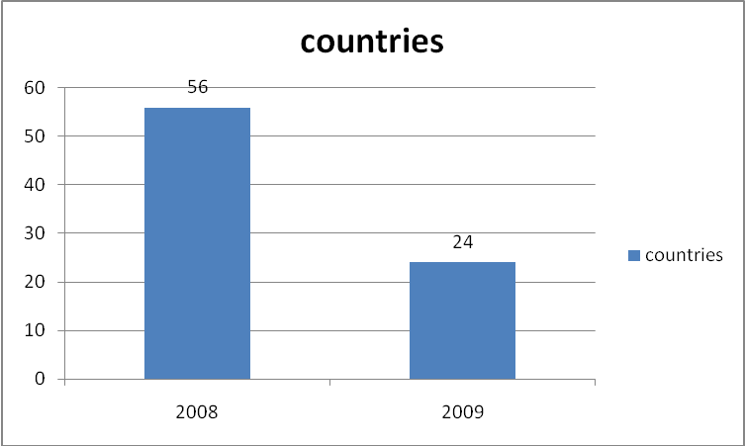

AMOUNTS RELATED TO THE FREEZING ORDERS BY MONTH AND CURRENCY (01/01/2009 TO 30/4/2009)

2009  (01/01/2009 -30/4/2009) | EURO | USD | GBP
JANUARY | 969.548,28
FEBRUARY | 7.534.356,25 | 266.533,00
MARCH | 140.274.58 | 30.927,00 | 43.940,73
APRIL | 129.863,38
TOTAL | 8.774.042,49 | 297.460,00 | 43.940.73

