HELLENIC ANTI-MONEY LAUNDERING AND ANTI-TERRORISM FINANCING COMMISSION (H.A.M.L.C.)

Statistics

Evolution over the last 2 years

 | 2007 | 2008
NUMBER OF DISCLOSURES RECEIVED | 1432 | 2899
NUMBER OF CASES OPENED | 1293 | 2077
NUMBER OF CASES FOR INVESTIGATION | 714 | 1102
NUMBER OF CASES CLOSED WITHIN THE FIU | 588 | 872
NUMBER OF CASES RESULTING IN PROSECUTIONS | 126 | 103
NUMBER OF CASES RESULTING IN SEIZURE OF ASSETS | 3 | 10
REQUESTS TO FIUS | 10 | 42

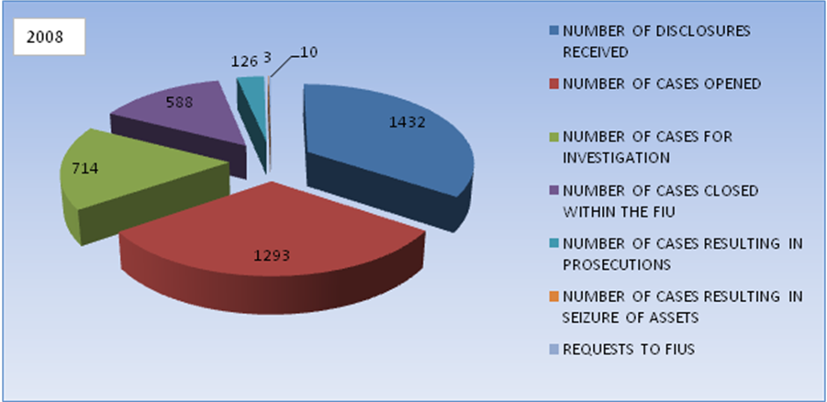

BREAKDOWN OF THE REQUESTS FOR INFORMATION RECEIVED FROM FIU COUNTERPARTS – EVOLUTION OVER THE LAST 2 YEARS

Country | 2007 | 2008
ALBANIA |  | 3
ARMENIA | 1
AUSTRIA |  | 6
BAHAMAS
BELGIUM | 11 | 7
BOLIVIA | 2
BRAZIL |  | 1
BULGARIA | 14 | 4
CROATIA | 2
CYPRUS | 9 | 7
CZECH REPUBLIC
DENMARK |  | 1
F.Y.R.O.M. | 3 | 1
FINLAND
FRANCE | 2 | 2
GEORGIA |  | 1
GERMANY | 2
GUATEMALA | 1
HUNGARY | 3
INDIA |  | 1
IRELAND | 1
ISLE OF MAN |  | 1
ISRAEL
ITALY |  | 1
LATVIA | 4
LUXEMBOURG | 3 | 5
MALTA
MOLDOVA | 1 | 4
MONTENEGRO |  | 2
NIGERIA | 1
PANAMA |  | 1
PHILIPPINES | 2
POLAND | 2
PORTUGAL |  | 1
QATAR |  | 3
ROMANIA | 8 | 11
RUSSIA | 2
SERBIA |  | 1
SLOVAKIA
SPAIN
ST. VINCENT & THE GRENADINES |  | 1
STATES OF JERSEY | 1 | 1
SWEDEN
SWITZERLAND | 1
TAIWAN | 1 | 31
THE NETHERLANDS | 1 | 2
TURKEY | 1
U.S.A. | 2 | 2
UKRAINE | 2 | 2
UNITED KINGDOM | 5 | 2
VENEZOUELA | 2
SLOVENIA |  | 1
TOTAL | 90 | 106

